

A Project Report On

**Hospital Management System**

**By**

**Bhavana V**

**B.E**

**Batch:** 2021 – 5883

**Center: Bangalore**

Under the Guidance of,

**Mamta Boga**

**Technical Trainer**

**Edu Bridge**

(School of coding)

**Introduction:**

Our project explains about the Hospital Management System. This project mainly explains the various actions related to doctor, patient and admin. You can search various appointments and admin can view various doctors who is there in the hospital or not.

Our Project Include **Modules:-**

* Admin Module
* Doctor Module
* Patient Module

I have developed this Application in **Java, JSP, Servlets, Hibernate, Spring Boot and MySQL.** It’s a web-based projects so I have used **HTML, CSS, JavaScript and Bootstrap also**.

The main feature of the project is to Take appointment easier. You can access this website from anywhere and everywhere.

In Admin module, admin can add the doctor and can delete doctor in the specific module. He can also view the total number of doctors and users at present in the website. And doctor and patient details also. Admin can only see the admin page and if he wants to delete and add doctors or patient appointment reviews.

In Doctor module, patient can access the website and take appointment by seeing the consult doctor in the doctor history. New doctor can register and login after that he can access the appointment history too.

In Patient module, patient can register if he is a new patient and take appointment to the consult doctor if necessary or can cancel the appointment within short interval of time. If patient is a member already he can take appointment to the consult doctor directly.

**Software Requirements:**

**Front end:** Java/J2EE technologies (Servlet, JSP), Spring boot, HTML,

CSS, JavaScript, Bootstrap, Hibernate.

**Back end**: MySQL workbench 8.0.23CE.

**Middleware/Server:** Apache Tomcat v7.5. IDE: Eclipse IDE or Mars for

Java EE Developers

**Browser:** Best result on Google Chrome

**Operating System:** Window 10

**Data Dictionary:**

Create Database Project;

* Hibernate: create table doctorlogin (username varchar(255) not null autoincrement , password varchar(255), primary key username)
* Hibernate: create table login (username varchar(255) not null autoincrement, password varchar(255),primary key username)
* Hibernate: create table patient (patientid int not null autoincrement, email varchar(255),mobile bigint,name varchar(255),password(255),patientid primary key, mobile not null)

# Screenshots:-

**Home Page:**



**Login Page:**

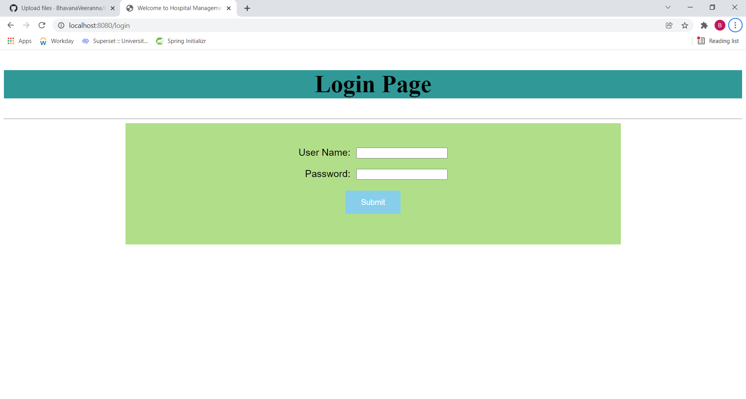

**Doctors details:**

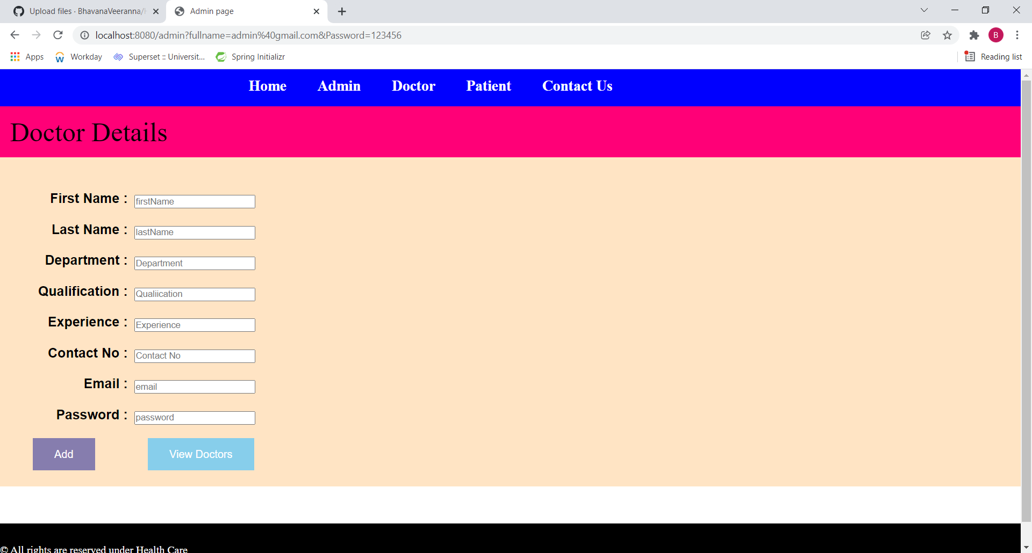

**Doctor List:**

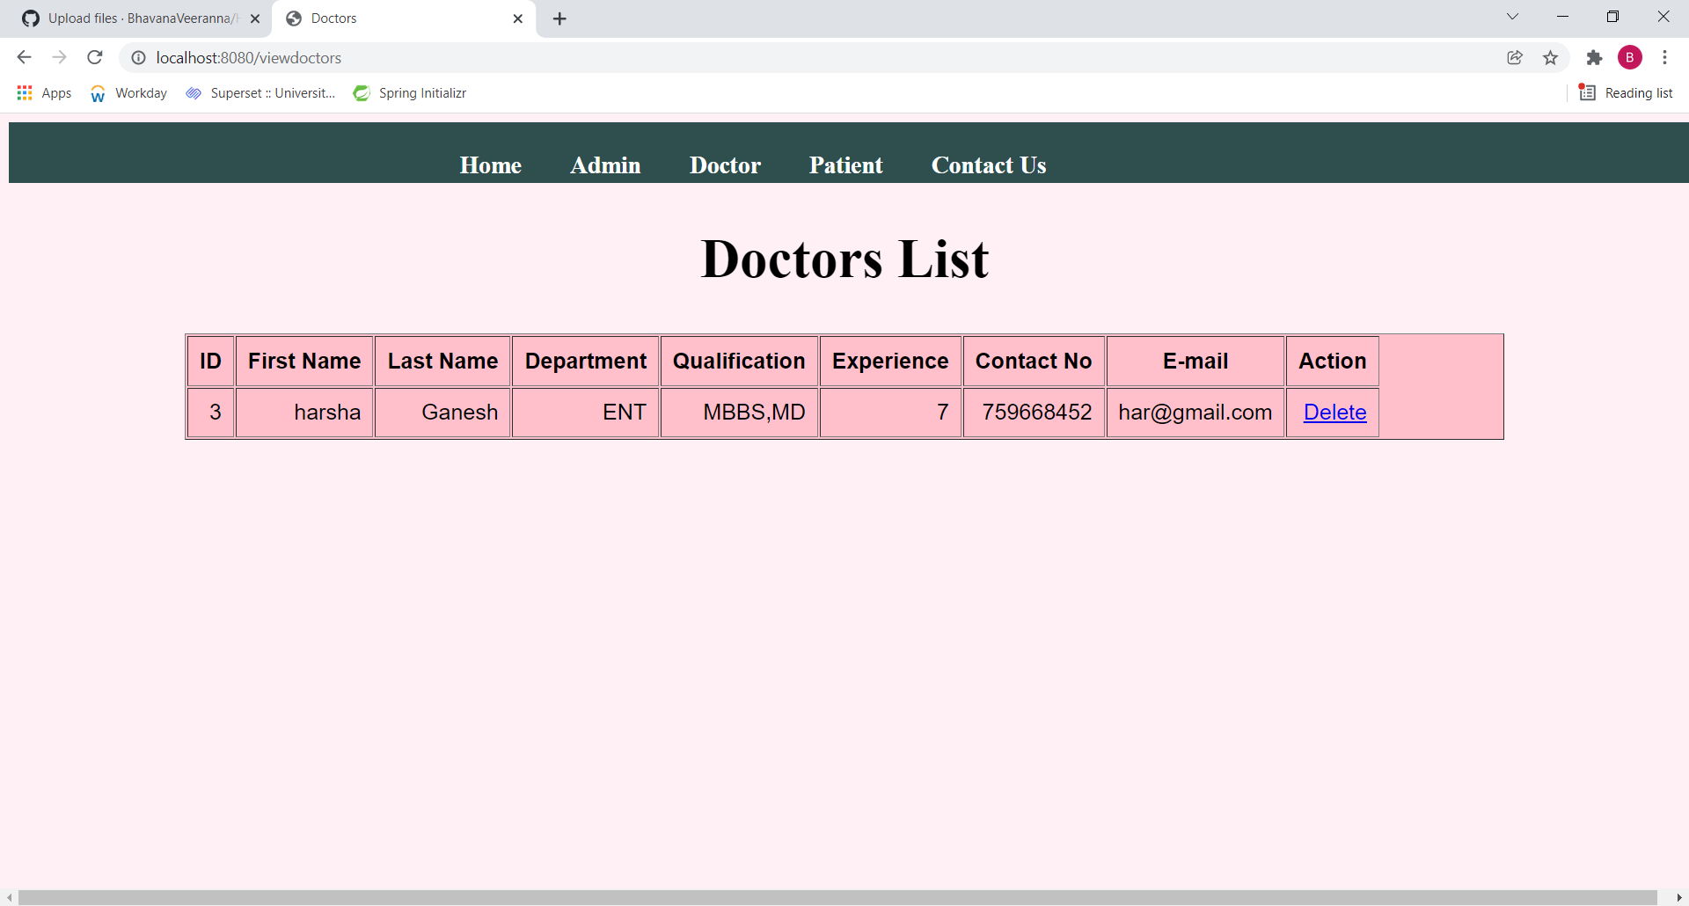

**Patient Appointment details:**

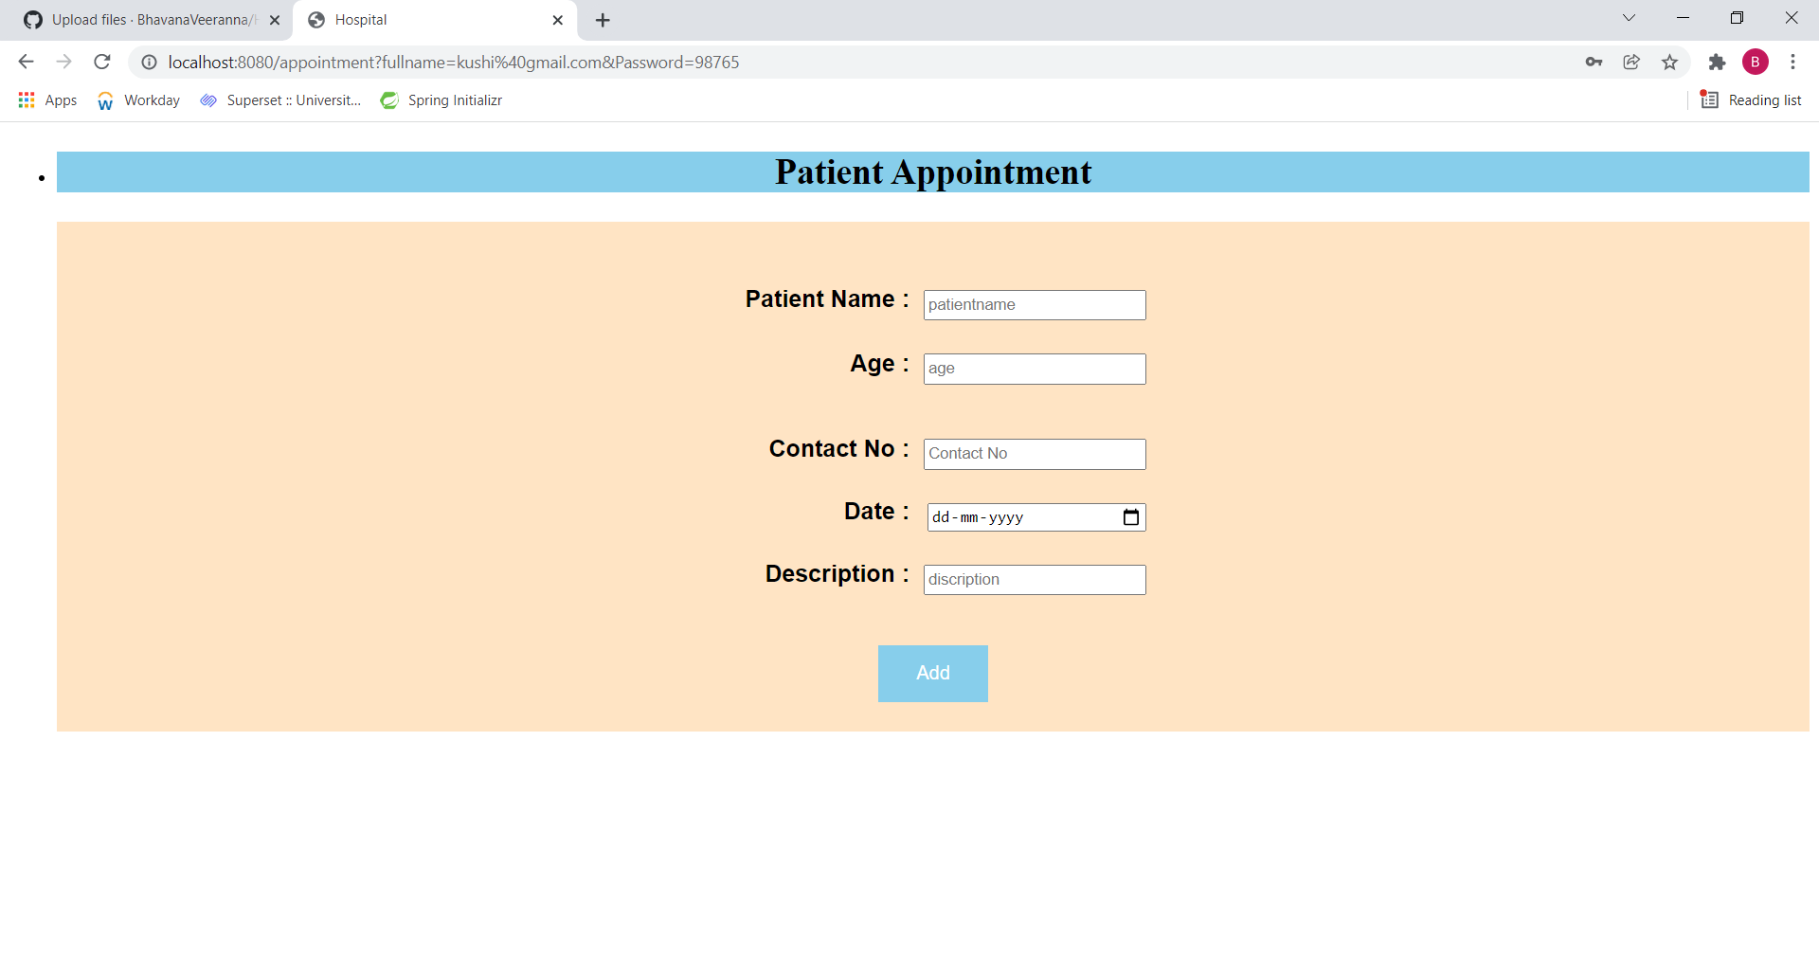

**Patient Login:**

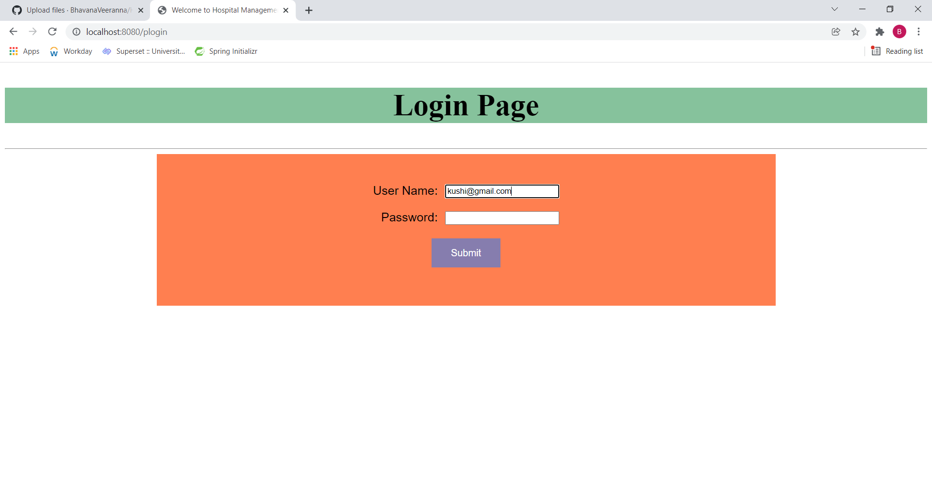

**New Patient Registration:**

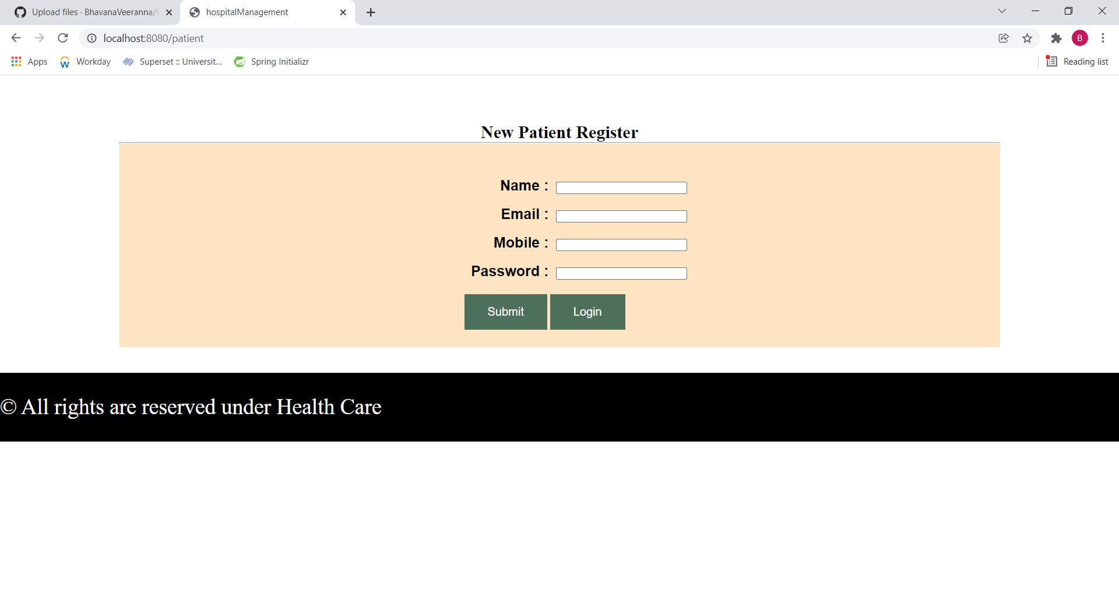

**Appointment list of Patient:**

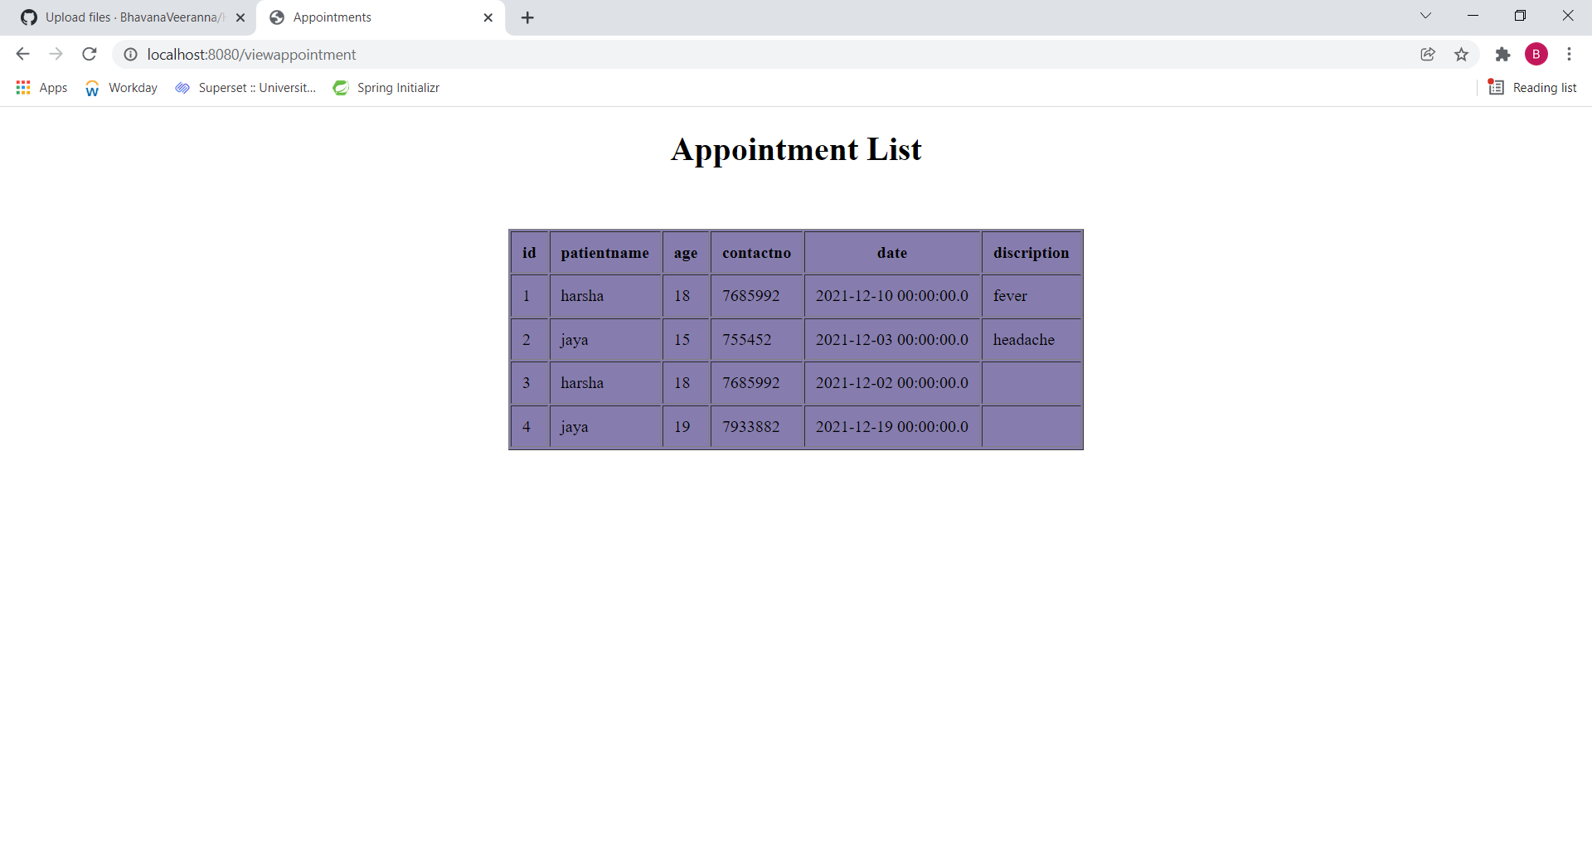

**Doctor login page:**

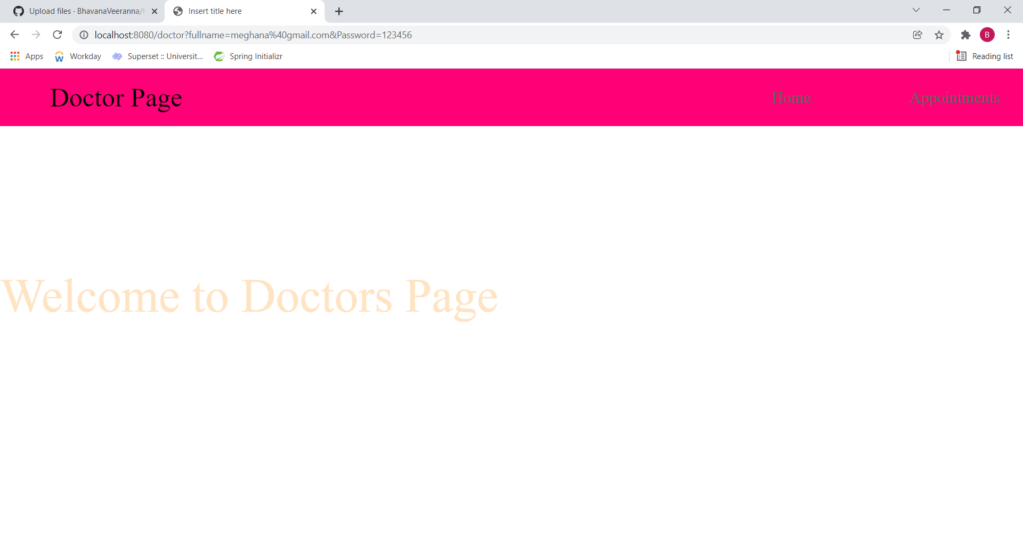

**Doctor Login:**

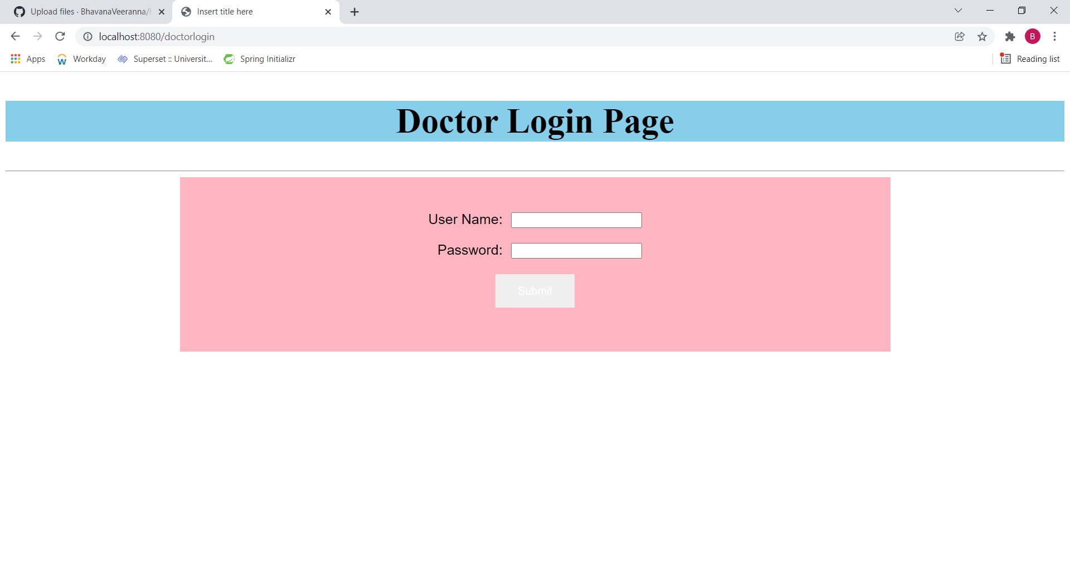

**Doctor List:**



**Appointment Booked successfully:**

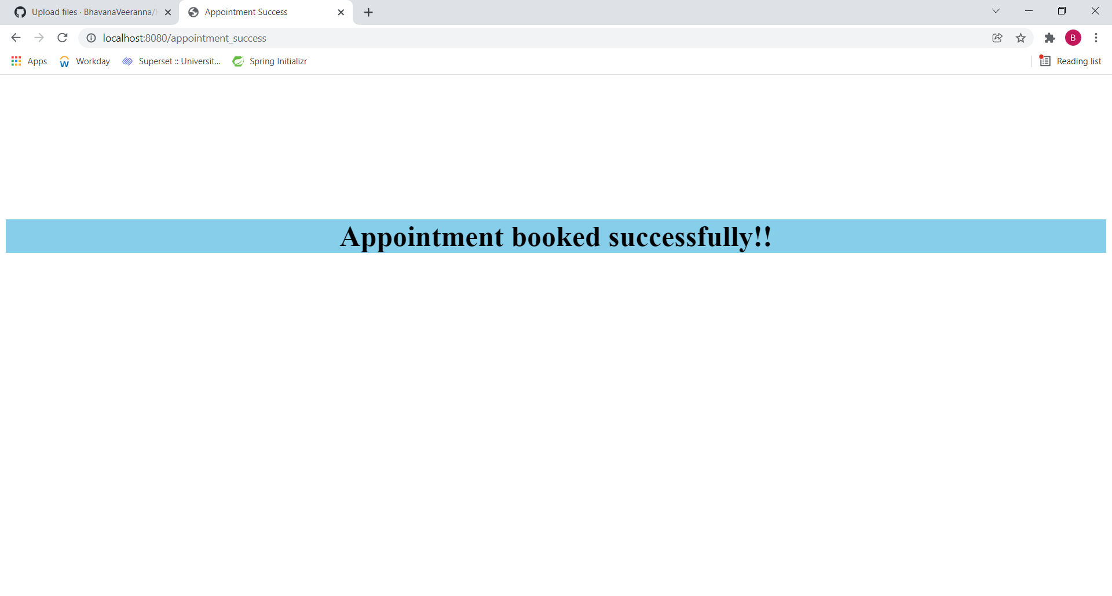

**Data Added in Database SuccessFully:**

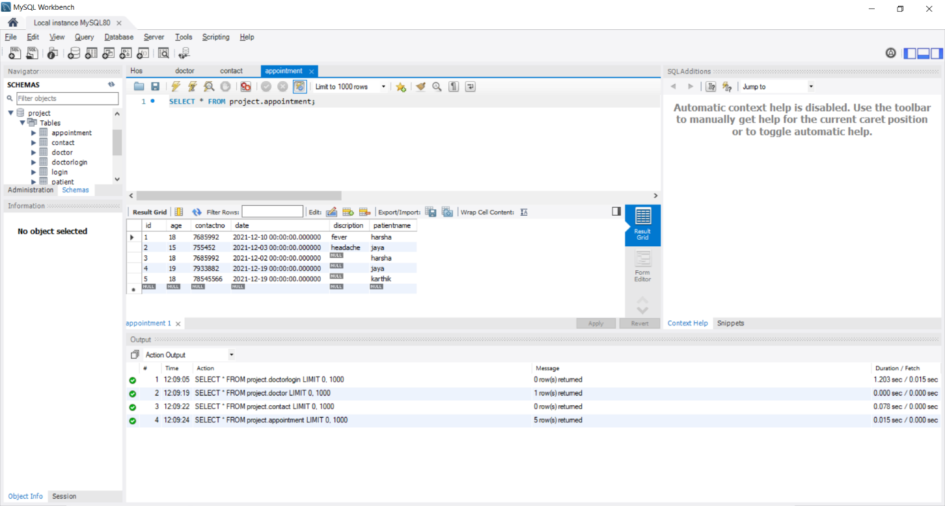

**Contact us:**

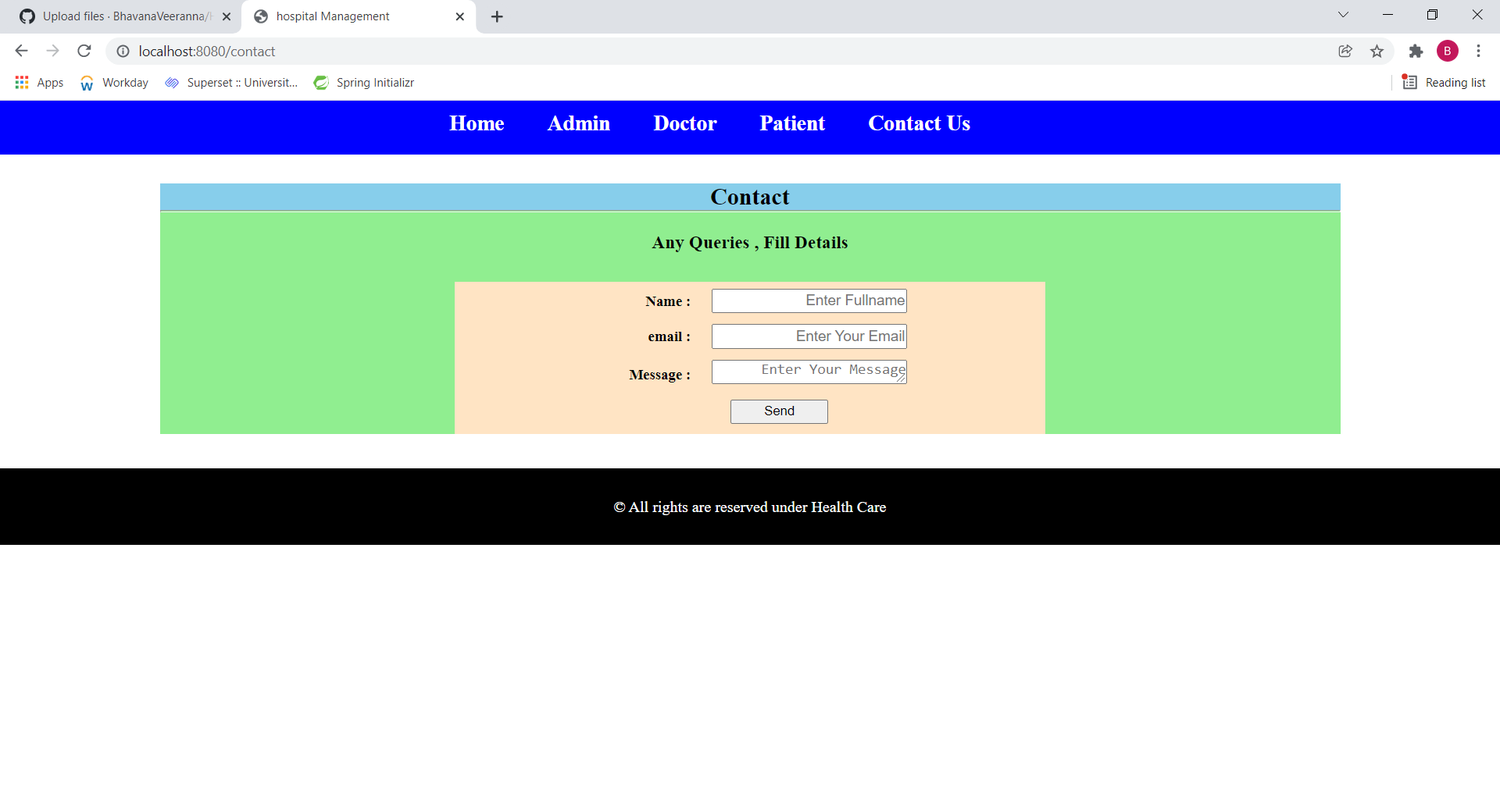

**Thank you**